Regional Operational Plan DF.#R.YY-XX

Operational Plan: Threemile Lake Invasive Northern Pike Suppression and Chuitbuna Lake Population Assessment

by

Parker Bradley, Cody Jacobson, and Kristine Dunker

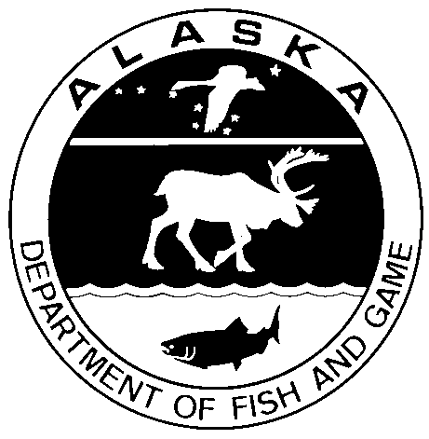

April 2019

Alaska Department of Fish and Game Divisions of Sport Fish and Commercial Fisheries

Symbols and Abbreviations

The following symbols and abbreviations, and others approved for the Système International d'Unités (SI), are used without definition in the following reports by the Divisions of Sport Fish and of Commercial Fisheries: Fishery Manuscripts, Fishery Data Series Reports, Fishery Management Reports, and Special Publications. All others, including deviations from definitions listed below, are noted in the text at first mention, as well as in the titles or footnotes of tables, and in figure or figure captions.

**Weights and measures (metric)**

centimeter cm

deciliter dL

gram g

hectare ha

kilogram kg

kilometer km

liter L

meter m

milliliter mL

millimeter mm

**Weights and measures (English)**

cubic feet per second ft3/s

foot ft

gallon gal

inch in

mile mi

nautical mile nmi

ounce oz

pound lb

quart qt

yard yd

**Time and temperature**

day d

degrees Celsius °C

degrees Fahrenheit °F

degrees kelvin K

hour h

minute min

second s

**Physics and chemistry**

all atomic symbols

alternating current AC

ampere A

calorie cal

direct current DC

hertz Hz

horsepower hp

hydrogen ion activity pH

(negative log of)

parts per million ppm

parts per thousand ppt,

‰

volts V

watts W

**General**

Alaska Administrative

Code AAC

all commonly accepted

abbreviations e.g., Mr., Mrs., AM, PM, etc.

all commonly accepted

professional titles e.g., Dr., Ph.D.,

R.N., etc.

at @

compass directions:

east E

north N

south S

west W

copyright ©

corporate suffixes:

Company Co.

Corporation Corp.

Incorporated Inc.

Limited Ltd.

District of Columbia D.C.

et alii (and others) et al.

et cetera (and so forth) etc.

exempli gratia

(for example) e.g.

Federal Information

Code FIC

id est (that is) i.e.

latitude or longitude lat. or long.

monetary symbols

(U.S.) $, ¢

months (tables and

figures): first three

letters Jan,...,Dec

registered trademark ®

trademark ™

United States

(adjective) U.S.

United States of

America (noun) USA

U.S.C. United States Code

U.S. state use two-letter abbreviations (e.g., AK, WA)

**Mathematics, statistics**

*all standard mathematical*

*signs, symbols and*

*abbreviations*

alternate hypothesis HA

base of natural logarithm *e*

catch per unit effort CPUE

coefficient of variation CV

common test statistics (F, t, χ2, etc.)

confidence interval CI

correlation coefficient

(multiple) R

correlation coefficient

(simple) r

covariance cov

degree (angular ) °

degrees of freedom df

expected value *E*

greater than >

greater than or equal to ≥

harvest per unit effort HPUE

less than <

less than or equal to ≤

logarithm (natural) ln

logarithm (base 10) log

logarithm (specify base) log2, etc.

minute (angular) '

not significant NS

null hypothesis HO

percent %

probability P

probability of a type I error

(rejection of the null

hypothesis when true) α

probability of a type II error

(acceptance of the null

hypothesis when false) β

second (angular) "

standard deviation SD

standard error SE

variance

population Var

sample var

Regional Operational plan DF.#R.YY-XX

**Threemile Lake Invasive Northern pike suppression and Chuitbuna Lake population assessment**

by

Parker Bradley, Cody Jacobson, and Kristine Dunker

Alaska Department of Fish and Game, Division of Sport Fish, Anchorage

Alaska Department of Fish and Game  
Division of Sport Fish

April 2019

The Regional Operational Plan Series was established in 2012 to archive and provide public access to operational plans for fisheries projects of the Divisions of Commercial Fisheries and Sport Fish, as per joint-divisional Operational Planning Policy. Documents in this series are planning documents that may contain raw data, preliminary data analyses and results, and describe operational aspects of fisheries projects that may not actually be implemented. All documents in this series are subject to a technical review process and receive varying degrees of regional, divisional, and biometric approval, but do not generally receive editorial review. Results from the implementation of the operational plan described in this series may be subsequently finalized and published in a different department reporting series or in the formal literature. Please contact the author if you have any questions regarding the information provided in this plan. Regional Operational Plans are available on the Internet at: <http://www.adfg.alaska.gov/sf/publications/>

Kristine Dunker, Parker Bradley and Cody Jacobson

Alaska Department of Fish and Game, Division of Sport Fish,

333 Raspberry Road,

Anchorage, AK

99518-1565

This document should be cited as:

P. Bradley, C. Jacobson, and K. Dunker. 2019. Threemile Lake Invasive Northern Pike Suppression and Chuitbuna Lake Population Assessment. Alaska Department of Fish and Game, Regional Operational Plan ROP.DF#R.YY-XX, Anchorage.

The Alaska Department of Fish and Game (ADF&G) administers all programs and activities free from discrimination based on race, color, national origin, age, sex, religion, marital status, pregnancy, parenthood, or disability. The department administers all programs and activities in compliance with Title VI of the Civil Rights Act of 1964, Section 504 of the Rehabilitation Act of 1973, Title II of the Americans with Disabilities Act (ADA) of 1990, the Age Discrimination Act of 1975, and Title IX of the Education Amendments of 1972.

**If you believe you have been discriminated against in any program, activity, or facility please write:**

ADF&G ADA Coordinator, P.O. Box 115526, Juneau, AK 99811-5526

U.S. Fish and Wildlife Service, 4401 N. Fairfax Drive, MS 2042, Arlington, VA 22203

Office of Equal Opportunity, U.S. Department of the Interior, 1849 C Street NW MS 5230, Washington DC 20240

**The department’s ADA Coordinator can be reached via phone at the following numbers:**

(VOICE) 907-465-6077, (Statewide Telecommunication Device for the Deaf) 1-800-478-3648,

(Juneau TDD) 907-465-3646, or (FAX) 907-465-6078

**For information on alternative formats and questions on this publication, please contact:**

ADF&G, Division of Sport Fish, Research and Technical Services, 333 Raspberry Rd, Anchorage AK 99518 (907) 267-2375

Signature Page

|  |  |
| --- | --- |
| Project Title: | Threemile Lake Invasive Northern Pike Suppression and Chuitbuna Lake Population Assessment |
| Project leader(s): | Parker Bradley, Cody Jacobson, and Kristine Dunker |
| Division, Region, and Area | Division of Sport Fish, Region II, Palmer Office |
| Project Nomenclature: | Northern pike, Invasive species, Threemile Lake, Chuitbuna, Lake, Population Assessment, Mark-Recapture, Suppression |
| Period Covered | May 2019 through December 2019 |
| Field Dates: | June 1–20, 2019 |
| Plan Type: | Category II |

**Approval**

|  |  |  |  |  |  |  |
| --- | --- | --- | --- | --- | --- | --- |
| Title |  | Name |  | Signature |  | Date |
| Regional Invasive Species Coordinator |  | Kristine Dunker |  |  |  |  |
| Project co-leader |  | Parker Bradley |  |  |  |  |
| Project co-leader |  | Cody Jacobson |  |  |  |  |
| Biometrician |  | Ben Buzzee |  |  |  |  |
| Research Coordinator |  | Tim McKinley |  |  |  |  |

TABLE OF CONTENTS

Page

list of Figures ii

List of Appendicies ii

INTRODUCTION 3

Objectives 5

Study Area 5

Methods 7

Background 7

Study Design 8

Chuitbuna Lake Northern Pike Population Estimate 8

Evaluation of Assumptions 10

Threemile Lake Northern Pike Suppression 11

Data Collection 12

Chuitbuna Lake Northern Pike Population Estimate 12

Threemile Lake Northern Pike Suppression 13

Data Analysis 13

Chuitbuna Lake Northern Pike Population Estimate 13

Schedule and Deliverables 14

Literature Cited 16

APPENDICES 17

Definitions 20

Size-Selective Sampling: KS Tests 20

Sex-Selective Sampling: Chi-Square **Tests** 20

**Composition estimation for stratified estimates** 1

**Tests of Consistency for Petersen Estimator** 2

# list of Figures

Figure 1. Northern pike range in Alaska. 3

Figure 2. Map of the Tyonek Area Watershed. 6

Figure 3. Map of study area. 7

Figure 4. Chuitbuna Lake divided into two sections for the mark-recap population estimate. 9

Figure 5. Threemile Lake Complex. Lake sections delineated in red. 12

# List of Appendicies

Appendix 1. Northern Pike Capture Form 18

Appendix 2. Northern Pike Stomach Sampling Form 19

Appendix 3. Detection and mitigation of selective sampling during a two-event mark recapture experiment. 20

# INTRODUCTION

The northern pike (*Esox Lucius*) is an invasive species in Southcentral Alaska that is steadily devastating salmonid populations through juvenile salmon predation in invaded waters (ADF&G 2007). The effects of this are most severe in shallow, slow moving, vegetated lakes and streams where pike and rearing salmonids share complete habitat overlap (Sepulveda et al. 2013 and 2014). Northern pike are native throughout much of the state but do not naturally occur south and east of the Alaska Range (Figure 1). They were introduced by anglers to the Yentna River drainage in the late 1950’s and subsequently spread throughout the Susitna River basin through flood events and further illegal stockings (Mills 1986). Today northern pike have been documented from over 120 lakes and rivers in Southcentral Alaska.

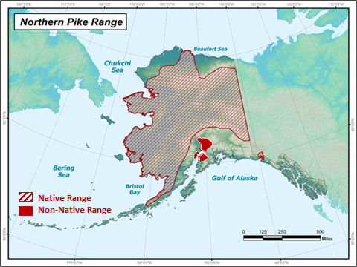

Figure . Northern pike range in Alaska.

More recently, smaller-scale “secondary” northern pike infestations (ex. originating from the Susitna infestation) have been reported widely throughout small, coastal-run stream systems throughout Cook Inlets’ western coast (herein referred to as West Cook Inlet). West Cook Inlet is off the road system, sparsely populated, and home to hundreds of small, complex, salmon-producing stream systems. Many reports of northern pike presence have come from sport and subsistence anglers; however, most reports lack live or dead specimens, preventing conclusive identification and knowledge of the extent of infestation.

The Tyonek Tribal Conservation District’s (TTCD’s) initial northern pike assessments in the West Side Cook Inlet drainages between 2015 and 2017 (Swenson and Hagan 2017) documented northern pike from several area waters (Threemile Lakes, Chuitbuna Lake, and Second Lake), though much uncertainty remains regarding overall northern pike distribution in the region. Based on those assessments documenting a low species richness in the lakes, and community observations, Threemile Creek drainage was prioritized as the most significantly impacted system in which pike were affecting salmon. However, the Chuitbuna, Indian Creek Drainage (Second Lake) are of concern for communities in the area as well and are planned for control efforts as resources become available. Threemile Creek drainage is located between the communities of Beluga and the Native Village of Tyonek and historically relied upon for subsistence, sport, and commercial harvest.

The Native Village of Tyonek (NVT) is a Dena’ina Athabascan village located 43 miles southwest of Anchorage, along the Cook Inlet, and is home to approximately 200 people. There are no roads to Tyonek which necessitate access via boat or small aircraft. The remote setting and cultural heritage of NVT makes subsistence activities of paramount importance with many of these activities focused on salmon. The total subsistence harvest for Tyonek in 2013 was 16,766 total pounds of salmon or 118 pounds per capita (Jones et al 2015). Although Threemile Creek is located about 3 miles north of Tyonek, northern pike in that system are suspected of reducing salmon populations in Threemile Creek, and therefore, decreasing the number of salmon returning along the West Cook Inlet beaches where Tyonek’s subsistence fishing occurs. Additionally, the outlet creek of Chuitbuna Lake provides rearing habitat for juvenile coho salmon. With northern pike thriving in the Threemile and Chuitbuna drainages without established containment or control, their potential to continue spreading into surrounding waterbodies in and around Tyonek and into vulnerable drainages along the West Side of Cook Inlet remains high without management intervention.

Survey data collected to date suggest the Threemile drainage has been the most severely affected of the surveyed waters. As a result, ADF&G partnered with TTCD and CIAA in 2018 to conduct an initial population assessment and suppression event in the Threemile Lake Complex which includes Threemile Lake, West Threemile Lake, Lower Lilly Pad Lake, and Upper Lilly Pad Lake. Results suggest that the initial suppression event successfully removed more than half (57%) of the northern pike population ≥ 300 mm fork length (FL). This lake complex is a strong candidate for annual invasive northern pike suppression, similar to ongoing efforts in Alexander Creek (Rutz et al. 2019). Initiating an effort like this could directly benefit salmon populations and both subsistence and sport fisheries in the Tyonek region. Most importantly, management of this invasive northern pike population might also hinder expansion of northern pike to other vulnerable drainages along West Cook Inlet. With Chuitbuna Lake being easily accessible and also containing a northern pike population, ADF&G and TTCD will attempt to estimate the population size of northern pike in the lake, assess specific northern pike population characteristics, and begin an initial suppression program.

The mission of ADF&G’s Sport Fish Division is “to protect and improve the state’s recreational fisheries resources”, and an objective of the Division’s strategic plan is to “minimize impacts of invasive species on fish stocks, recreational fisheries, and fish habitat”. Removing northern pike from vital salmon rearing habitat directly relates to this objective. ADF&G has an aquatic nuisance species management plan (ADF&G 2002) and an invasive northern pike management plan (ADF&G 2007). Goals and objectives in these plans address the need to remove invasive northern pike where possible and improve salmon populations that have been impacted by northern pike. The activities proposed in this project are aligned with several plans and initiatives, and ADF&G believes this project will provide the first step in a long-term initiative to effectively suppress the invasive northern pike population in the Threemile Drainage and Chuitbuna Lake.

# Objectives

This project will lay the foundation from which a long-term northern pike suppression program can be effectively designed and evaluated by estimating the population size of northern pike in Chuitbuna Lake, while continuing suppression efforts in the Threemile Drainage. Specific objectives for this current project include:

1. Estimate the population size of northern pike > 300 mm FL in Chuitbuna Lake such that the estimate is within 25% of the true population size 90% of the time.
2. Suppress the northern pike population in the Threemile Lake complex using angling and overnight gillnet sets.

**Secondary Objectives:**

1. Calculate the mean fork length (FL) and length range of northern pike in Chuitbuna Lake and the Threemile Lake Complex.
2. Document stomach contents, sex, weights, and age of northern pike in Chuitbuna Lake and the Threemile Lake Complex.

# Study Area

This project will take place in the Tyonek Tribal Conservation District (TTCD). The TTCD shares its boundaries with Alaska Game Management Unit 16B. The District’s eastern edge is the Susitna River, its northern and western boundaries are the divide of the Alaska Range, and its southern border is Cook Inlet. Population and infrastructure in the region is limited but is centered on the Tyonek-Beluga corridor. The Tyonek-Beluga corridor hosts a population of roughly 200 people, hosts over 80 miles of unimproved roads and has 3 airstrips. Waterbodies in proximity to this small population corridor are classified as the Tyonek Area Watershed (Figure 2). The watershed has 378 lakes and approximately 1,624 river miles of freshwater and is home to all 5 species of Pacific salmon. Juvenile salmonids are preferred prey for northern pike and the negative effects of northern pike infestations on salmonid populations in the region is well documented (Sepulveda et al. 2013).

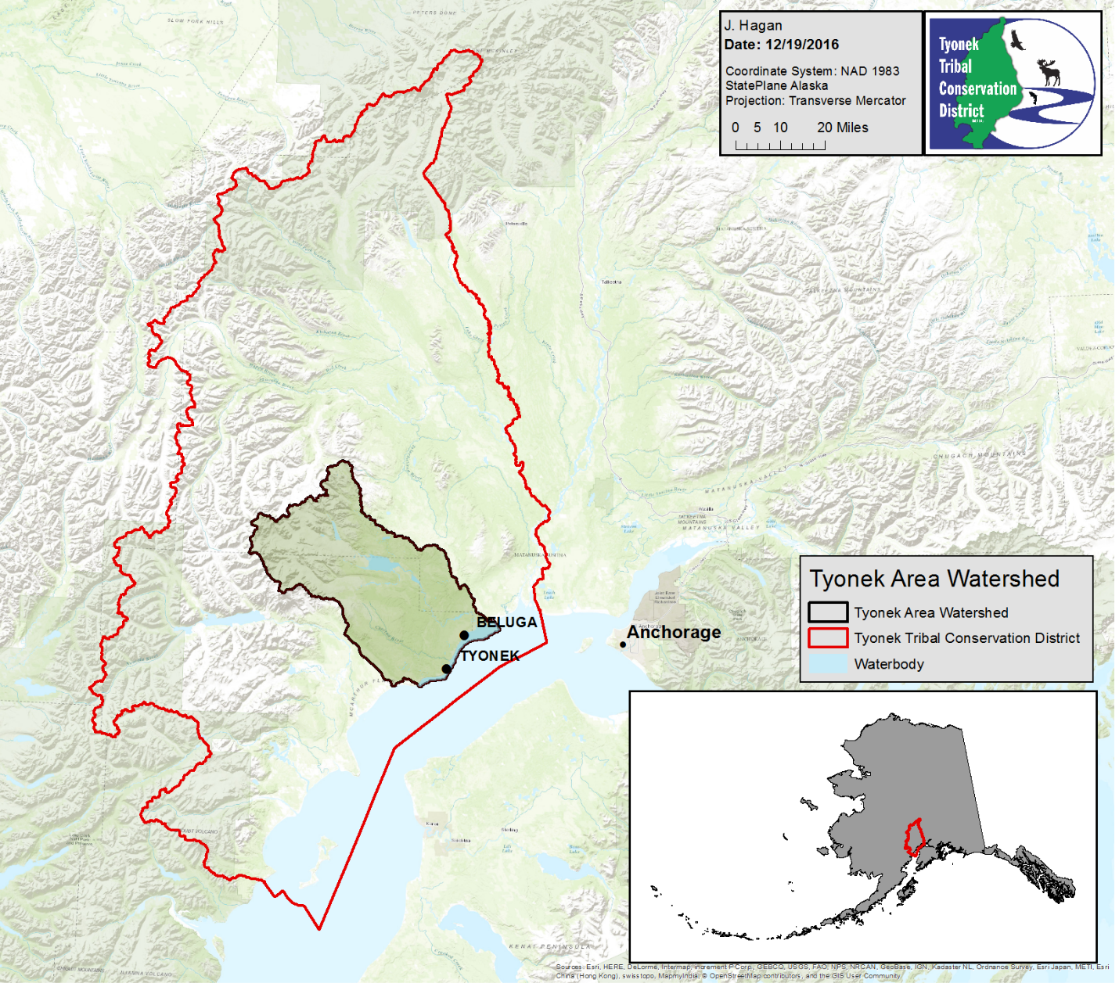

Figure . Map of the Tyonek Area Watershed.

Waterbodies with direct access to the Tyonek-Beluga road system are the most heavily used for sport and subsistence fishing activities. The Threemile Lake Complex has several access points including a motorized watercraft launch accessible by ATV and is the most heavily used area for sport fishing activities in the region while Chuitbuna Lake is accessible from the road system (Figure 3). The Threemile Creek watershed is a complex stream system covering 20.4 square miles. There are more than 20 inter-connected lakes and several more ephemeral lakes within the watershed. Due to the low-gradient landscape, flooding can connect closed lakes for periods of time and connect off-channel habitat and oxbows. The system is ground water dominated.

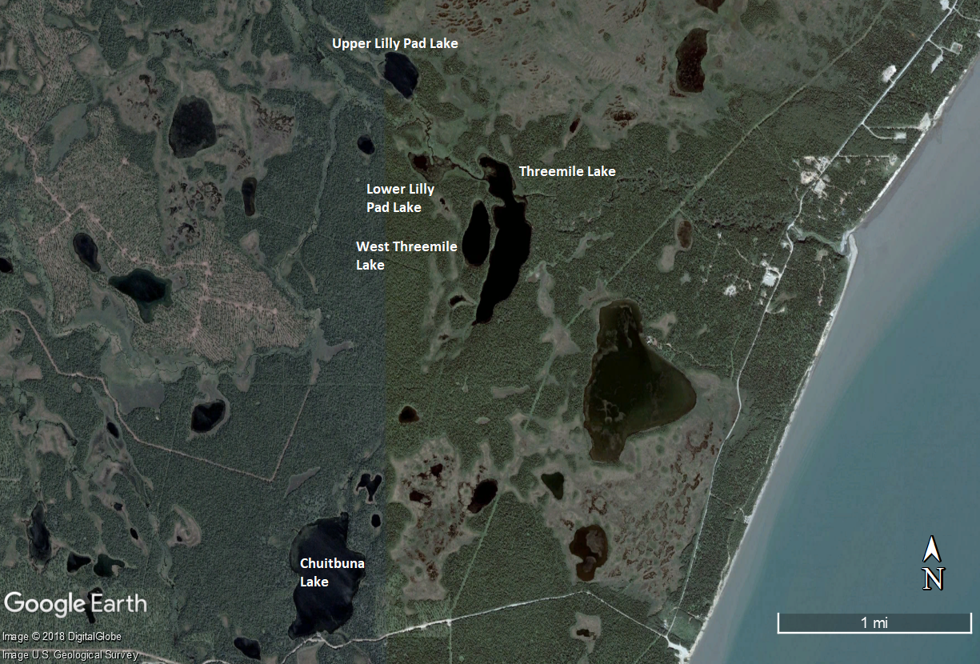

Figure . Map of study area.

# Methods

## Background

The long-range goal of the partnership between TTCD, NVT, CIAA and ADF&G is to reduce the impact of invasive northern pike on rearing salmonids by removing as many northern pike from Chuitbuna Lake and the Threemile Lake Complex as possible. Relieving some of the predation pressure on salmon fry and smolt should increase their abundance by contributing to greater survival (Muhlfeld et al. 2008). Over time, greater survival of juvenile salmon may result in larger annual returns of adult salmon that support sport and subsistence fisheries in the TTCD. Increased salmon productivity in the Threemile drainage coupled with reductions in the northern pike population could eventually drive the fish community toward equilibrium. In other parts of Alaska where northern pike are native, and even in other drainages in Southcentral where they are not (i.e. the Deshka River), northern pike and salmonids are capable of coexisting; however, habitat complexity that allows salmonids opportunities for predator avoidance is hypothesized to be a strong factor in mediating predator-prey interactions within these fish communities (Sepulveda et al. 2013). In the Threemile Lake Complex, where the habitat is relatively homogenous providing ideal conditions for northern pike, salmonids are unable to avoid predation and, hence, their populations can drastically decline (Dunker et al. 2018). Through annual suppression of the northern pike population in this area, the partnership hopes to eventually restore salmonid production to sustainable levels in the Threemile Creek Drainage.

To effectively design and implement an annual northern pike suppression program, there are some useful first steps. It is prudent to begin with a baseline estimate on the size of the northern pike population (i.e. Baxter and Neufeld 2015). In 2018, a population estimate was performed in combination with a suppression event which doubled as a recapture event in the Threemile drainage. In Threemile Lake, including Lower Lilly Pad Lake, it was estimated there were 1,063 ± 102 (95% CI) northern pike ≥ 300 mm prior to suppression. The suppression efforts reduced that population by 57%. In West Threemile Lake, it was estimated there were 45 ± 11 northern pike ≥ 300 mm prior to suppression. The suppression efforts reduced that population by 49%. Finally, in Upper Lilly Pad Lake, it was estimated there were 221 ± 70 northern pike ≥ 300 mm prior to suppression. Supression efforts reduced that population by 56%. These baseline data will facilitate future evaluation of the suppression program because direct comparisons can be made between this initial baseline and northern pike population levels following periods of suppression. Further, the abundance estimate can be used to model annual removal targets to increase the effectiveness of the suppression program and determine, on an annual basis, if suppression activities are successfully meeting those targets.

ADF&G’s annual northern pike suppression program in Alexander Creek is on-going, but an initial population estimate was not available. While there are favorable signs that the Alexander Creek northern pike suppression program is benefiting Chinook salmon production (Rutz et al. 2019), direct quantitative conclusions are difficult in the absence of baseline data on the initial northern pike population size. Future invasive northern pike suppression programs will now aim to begin with this initial assessment when feasible. Because the pilot year conducting a population estimate in the Threemile Lake Complex was successful, efforts will continue with suppression in that system, along with estimating an initial population size of northern pike in Chuitbuna Lake.

## Study Design

### Chuitbuna Lake Northern Pike Population Estimate

This study is designed to estimate the abundance of northern pike in Chuitbuna Lake (Figure 4) using two-event Petersen mark-recapture techniques for a closed population (Seber 1982). Such techniques are designed to satisfy the following assumptions:

1. the population is closed (northern pike do not enter the population, via growth or immigration, or leave the population, via death or emigration, during the experiment);
2. all northern pike will have a similar probability of capture during the first event or during the second event, or marked and unmarked northern pike will mix completely between events;
3. marking of northern pike will not affect the probability of capture during the second event;
4. marked northern pike will be identifiable during the second event; and,
5. all marked northern pike will be reported when recovered in the second event.

Failure to satisfy these assumptions may result in biased estimates; therefore, the study is designed to ensure these assumptions are reasonably valid.

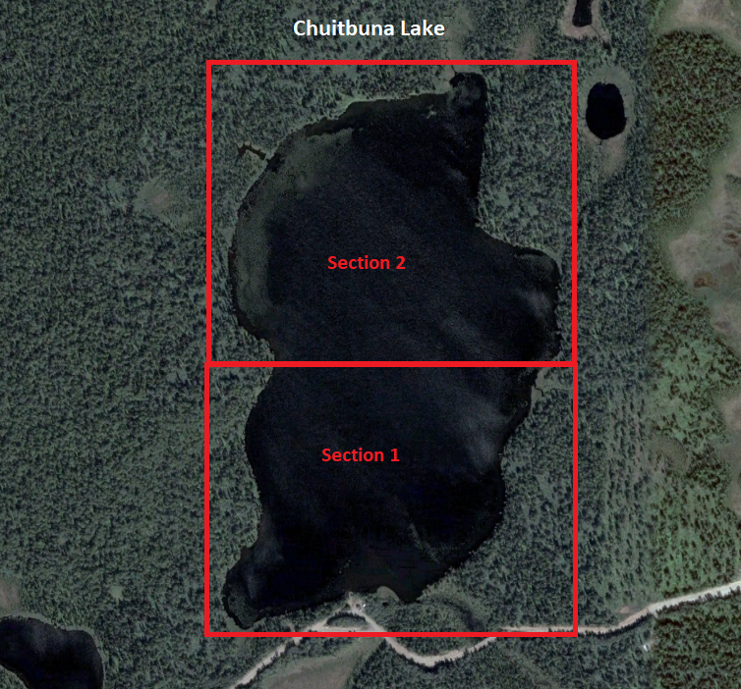

Figure . Chuitbuna Lake divided into two sections for the mark-recap population estimate.

*Sampling*

Fyke nets will be deployed as a barrier in the outlet of Chuitbuna Lake to prevent immigration and emigration of northern pike during the study and ensure that Assumption 1 is not violated. To aid in the evaluation of assumptions and ensure sampling effort is uniformly distributed, the lake complex has been divided into two sections (Figure 4). The mark event will take place between 1 June and 4 June, and the recapture event will take place 16 June to 20 June. During the mark event, at least two anglers will use hook and line gear and two crew members will deploy and monitor gillnets to sample northern pike for 8 hours each day over the course of four days. Up to 10 gillnets will be deployed each day in a given section along the littoral zone. Nets will be distributed uniformly in the littoral zone of each section, and locations will be recorded with GPS for repeatability. Throughout the sampling period, the crew will continuously boat along the nets and remove any northern pike that are captured. If it takes greater than 30 minutes between checking nets or the northern pike in the nets appear impaired from time spent in the nets, some of the gillnets may be removed to reduce capture or handling mortality. The angling crew will work in the opposite section from the gill net crew, and they will alternate the section they work in each day so that each section is sampled twice by both gear types. Captured northern pike will be measured for fork length (FL; mm) and all individuals ≥ 300 mm FL will be tagged with an individually numbered FloyTM T-bar tag and released where they were caught. Sample crews will record this data on the Northern Pike Capture Form (Appendix 1). FloyTM T-bar tags will be inserted through the proximal pterygiophore at the mid-length of the dorsal fin. A left pelvic fin clip will serve as a secondary mark to control for tag loss.

An 11-day hiatus interval will separate the mark event from the recapture event. Mixing of tagged and untagged individuals should occur within this timeframe but will be tested for during data analysis.

Similar methods will be employed during the recapture event except 20 gill nets will be used, and the gill nets will be left to soak overnight. All northern pike captured will be dispatched and examined for tags. Because all pike will be killed during this event, the recapture event will serve as the first opportunity to begin suppression of the northern pike population in Chuitbuna Lake. Though the recapture event will allow for opportunistic suppression during this project, a formal suppression plan for future years will be developed after the current project concludes. All northern pike in the recapture event will be immediately dispatched. Periodically throughout the day, dispatched northern pike will be brought over to a processing station where two crew members will measure each northern pike for fork length and weight, remove the otoliths and cleithrum for ageing, and dissect each northern pike to document stomach contents and sex. These data will be recorded on the Northern Pike Stomach Sampling Form (Appendix 2).

The fyke net will remain in place blocking the outlet for the duration of the study and will be monitored daily to ensure it is effectively preventing fish passage.

### Evaluation of Assumptions

**Assumption 1:** Assumption 1 will likely not be violated because the outlet of Chuitbuna Lake will functionally be blocked with a fyke net during this study. In addition, this study will be of short duration, and therefore, growth recruitment and mortality will be insignificant. Also, if during the mark event, northern pike are mortally injured (i.e. hook through the eye, bleeding gills, etc.) or seem unusually stressed, the fish will be sacrificed and processed (see Data Collection) rather than marked.

**Assumption 2:** We do not have evidence to suggest northern pike will mix completely during the 11-day hiatus. Therefore, Assumption 2 will be met by attempting to subject all fish to the same probability of capture during each sampling event. While angling and fishing with gillnets, fishing effort will be distributed in proportion to the distribution of northern pike. Based on catch rates and visual observations, effort will be increased in areas where densities appear relatively high (e.g., shallow vegetated bays and outlet areas) and decreased where there appear to be few fish available (e.g., deep water zones). Sample sizes are expected to be large enough to provide sufficient power for tests of heterogenous capture probabilities. Differences in capture probability related to fish size, sex, and location will be tested for as described in Appendix 3. If significant differences are detected, stratified estimates of abundance and its variance will be used.

**Assumption 3**: The hiatus between mark and recapture events should allow marked fish to recover from the effects of handling and marking during the first event; therefore, Assumption 3 should be valid. However, it is unknown if fish captured in gillnets during the mark event will avoid this gear during the recapture event, but the heavy use of hook and line sampling should mitigate such an effect, if it exists.

**Assumption 4:** This assumption will be addressed by double-marking each northern pike captured during the first event. Tag loss will be noted when a fish is recovered during the second event with a first-event fin clip but without a FloyTM tag. In addition, tag placement will be standardized, which will enable the fish handler to verify tag loss by locating recent tag wounds.

**Assumption 5:** All fish will be thoroughly examined for tags or recent fin clips. All markings (tag number, fin clip, and tag wound) for each fish will be recorded.

*Sample Size*

As stated previously, the abundance estimate for northern pike in Chuitbuna Lake established through this study will be used to model future northern pike suppression goals. This estimate will also serve as the baseline from which the northern pike suppression activities can be evaluated for their effectiveness. Since no previous estimates of abundance are available, we will use density estimates obtained from Upper Lilly Pad Lake—a nearby lake with similar habitat structure—to estimate the potential number of pike ≥ 300 mm in Chuitbuna Lake. In 2018, Upper Lilly Lake was estimated to have 221 pike ≥ 300 mm with .73 miles of coastline, or 303 pike per mile of coast. If the density of pike is similar, then we can expect a population of around 564 pike in Chuitbuna Lake (with 1.87 miles of coastline). Based on this estimate, 125 fish will need to be sampled during each sampling event to meet the precision criteria of objective 1 (Robson and Regier 1964).

An educated estimate of the sample sizes we can expect to obtain incorporates previous catch rates of pike in Chuitbuna Lake, and the available man power and allotted time for the project. In 2017 limited gill netting (250 net hours) resulted in capture of 25 pike (0.1 per gillnet hour). In 2018, targeted gill netting (for 8 hours) resulted in capture of 13 pike (1.6 per gillnet hour). Assuming 2017 results are the same for this study, a gillnetting crew fishing 10 gillnets for 8-hour sets per day for 4 days at a rate of 0.1 pike per net hour are likely to catch approximately 32 northern pike. This does not include fish the angling crew will catch. Given these values, a sufficient sample size for the mark event is anticipated.

### Threemile Lake Northern Pike Suppression

Results from initial suppression in 2018 showed a substantial portion (57%) of the population from the Threemile Lake complex could be removed in 10 days. Similar effort will be employed moving forward with the attempt to maintain a level of mortality in the population that exceeds recruitment so the population will decline over time.

*Sampling*

The sample area has been divided into 6 sections (Figure 5). A total of 20 gillnets will be utilized in this suppression event. For sections 1-4, 20 gillnets will be deployed in a given section, fished overnight, and moved to the next section the following day. Gill netting effort will be split between sections 5 and 6, with each section receiving 10 gillnets to be set overnight on the same night. After all sections have received the respective number of overnight gillnet sets (total of 5 nights), the gillnet sets will be repeated in each section for a total of 10 nights of netting effort (each section receiving two nights of netting). In addition, an angling crew (2-4 people) will sample sections 1-4 and section 6. Section 5 was not productive for anglers in 2018 and thus will not receive angling effort.

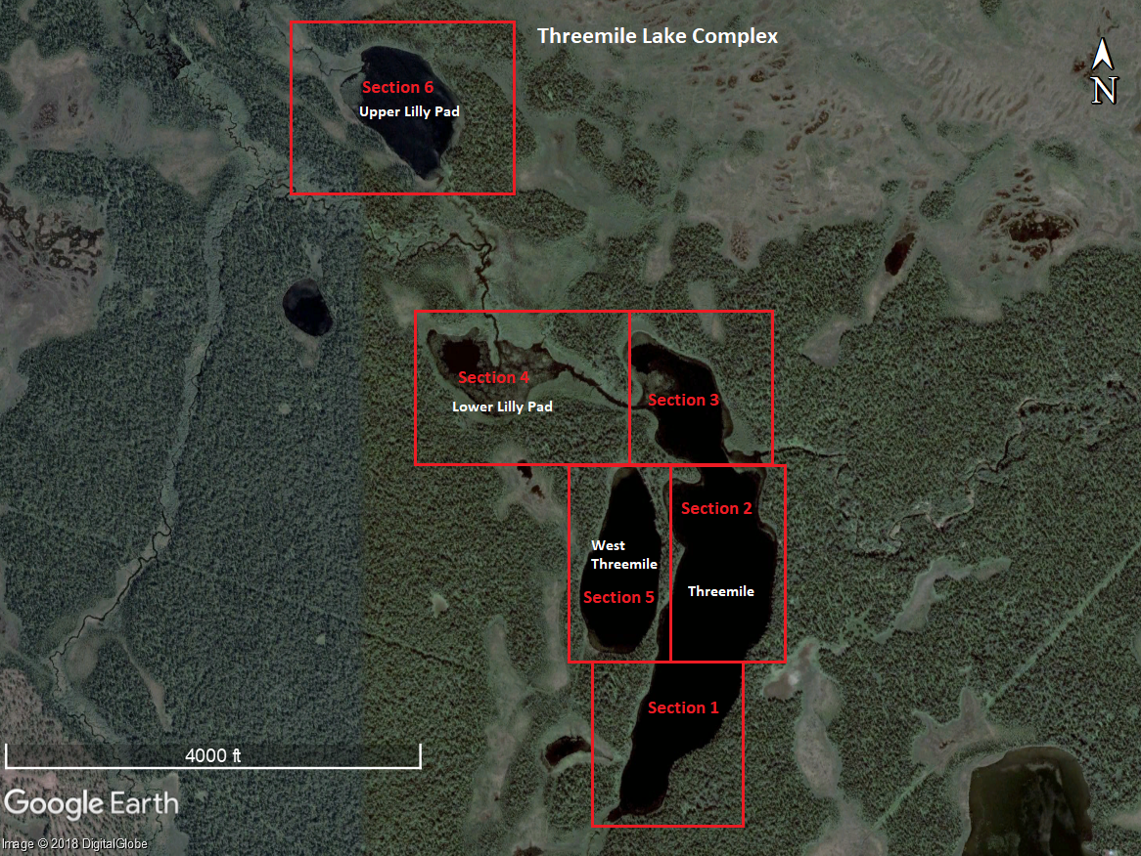

Figure . Threemile Lake Complex. Lake sections delineated in red.

All captured northern pike will be immediately dispatched and measured for fork length. Presence of tags from the 2018 mark/recapture study will be noted if present, along with tag number. These data will be recorded on the Northern Pike Catch Form (Appendix 1). Periodically throughout the day, dispatched northern pike will be brought over to a processing station where two crew members will measure each northern pike for fork length and weight, remove the otoliths, and dissect each northern pike to document stomach contents and sex. These data will be recorded on the Northern Pike Stomach Sampling Form (Appendix 2).

## Data Collection

### Chuitbuna Lake Northern Pike Population Estimate

All capture data will be recorded on water resistant paper following the format in Appendix 1. For each northern pike caught during the mark event ≥ 300 mm FL, its fork length and tag number will be recorded before being released. Any mark-event northern pike that die during handling and all recapture-event northern pike will be processed for fork lengths, weight, age (by counting annuli on cleithra bones), sex, stomach contents, and examined for a tag or tag loss. All data will be recorded on data sheets (Appendix 2). Also, any northern pike < 300mm FL will dispatched and processed in the same manner.

### Threemile Lake Northern Pike Suppression

All capture data and will be recorded on water resistant paper following the format in Appendix 1. Additionally, all captured northern pike will be dispatched and processed for fork lengths, weight, sex, stomach contents, and have otoliths removed. All data will be recorded on data sheets (Appendix 2).

## Data Analysis

### Chuitbuna Lake Northern Pike Population Estimate

*Abundance*

Abundance and its variance will be estimated with the Chapman’s modification of the Petersen estimator:

$$\hat{N}=\frac{\left(n_{1}+1\right)\left(n_{2}+1\right)}{\left(m_{2}+1\right)}-1$$

$$\hat{V}\left(\hat{N}\right)=\frac{\left(n_{1}+1\right)\left(n_{2}+1\right)\left(n_{1}-m_{2}\right)\left(n_{2}-m_{2}\right)}{{\left(m_{2}+1\right)}^{2}\left(m_{2}+2\right)}$$

where:

$n_{1}$ = the number of fish marked during the first sampling event;

$n_{2}$ = the number of fish examined during the second sampling event; and,

$m_{2}$ = the number of fish captured during the second event with marks from the first event.

If tests indicate heterogenous capture probabilities related to size, length, or location, a stratified estimate of abundance and its variance will be used (Appendix 3).

# Schedule and Deliverables

|  |  |
| --- | --- |
| May 2019: | Purchase equipment and field camp gear Confirm field crews  Transfer equipment |
| June 1-4: | Chuitbuna Lake Mark Event |
| June 5-15: | Threemile Lake complex northern pike suppression  Collect northern pike length, weight, sex, stomach data, and otoliths  Mixing event for Chuitbuna Lake |
| June 16-20: | Chuitbuna Lake Recapture Event  Collect northern pike length, weight, sex, stomach data, cleithra and otoliths |
| July 2019: | Data entry |
| Winter 2019: | Analyze data and write project report  Model future northern pike suppression targets |

RESPONSIBILITIES

Personnel: Kristine Dunker, Fishery Biologist III, Alaska Department of Fish and Game, Sport Fish Division

Duties: Provide oversight and make recommendations on study designs and project plans; assist with data analysis and project reporting; coordinate and assist with the completion of project deliverables.

Personnel: Parker Bradley, Fishery Biologist II, Alaska Department of Fish and Game, Sport Fish Division.

Duties: Serve as the primary project biologist; assist with planning and coordinating field logistics; Assist with project reporting and presentations to the public.

Personnel: Cody Jacobson, Fishery Biologist I, Alaska Department of Fish and Game, Sport Fish Division.

Duties: Assist with planning and coordinating field logistics and equipment procurement; Supervise field activities and technicians

Personnel: Ben Buzzee, Biometrician IV, Alaska Department of Fish and Game, Sport Fish Division.

Duties: Provide guidance on study design; Assist with post-season data analysis. Review project operational plans and reports.

Personnel: Nicole Swenson, Biologist, Tyonek Tribal Conservation District.

Duties: Provide guidance on study design; Coordinate field logistics and equipment procurement.

Personnel: Justin Trenton, Environmental Director, Native Village of Tyonek

Duties: Community outreach, field work, and equipment procurement.

Personnel: Andy Wizik, Biologist, Cook Inlet Aquaculture Association.

Duties: Provide guidance on study design; field assistance and equipment procurement.

In addition, one fish and wildlife technicians will be hired to assist with the field activities.

# Literature Cited

Alaska Department of Fish and Game. 2002. Aquatic Nuisance Species Management Plan. Alaska Department of Fish and Game. 55 pp.

Alaska Department of Fish and Game. 2007. Management Plan for Invasive Northern Pike in Alaska. Alaska Department of Fish and Game, Division of Sport Fish, Anchorage. 64 pp.

Conover, W. J. 1980. Practical nonparametric statistics 2nd ed. John Wiley & Sons, New York.

Baxter, J.T. and M. Neufeld. 2015. Lower Columbia River Northern Pike Suppression and Stomach Analysis – 2014. Final Report to Teck Trail Operations, British Columbia Ministry of Forests, Lands, and Natural Resource Operations, 28 pp.

Dunker, K., A. Sepulveda, R. Massengill, and D. Rutz. 2018. [The northern pike, a prized native but disastrous invasive.](https://www.crcpress.com/Biology-and-Ecology-of-Pike/Nilsson-Skov/p/book/9781482262902) Pages 356-398 [In] C. Skov and P. A. Nilsson, editors. Biology and ecology of pike. CRC Press, Boca Raton, FL.

Glick, W.J. and T.M. Willette. 2016. Relative abundance, food habits, age, and growth of northern pike in 5 Susitna River drainage lakes, 2009-2012. AK Dept. of Fish and Game, FDS No. 16-34, Anchorage.

Inskip, P. D. 1982. Habitat suitability model: northern pike. U.S. Department of Interior, Fish and Wildlife Service, FWS/OBS-82/10.17. 40pp.

C., Jacobson, K. Dunker and D. Rutz. 2016. Northern Pike Eradication in the Cottonwood Creek Drainage – Phase 1. Alaska Department of Fish and Game, Regional Operational Plan ROP.DF#R. YY-17, Anchorage.

Jones, B., D. Holen, and D. S. Koster. 2015. The harvest and use of wild resources in Tyonek, Alaska, 2013. Alaska

Department of Fish and Game Division of Subsistence, Technical Paper No. 404. Anchorage.

Massengill, R. L. 2010. Control efforts for invasive northern pike on the Kenai Peninsula, 2005-2006. Alaska Department of Fish and Game, Fishery Data Series No. 10-05, Anchorage.

Mills, M. J. 1986. Alaska statewide sport fish harvest studies - 1985 data. Alaska Department of Fish and Game, Federal Aid in Fish Restoration and Anadromous Fish Studies, Annual Performance Report 1985-1986, Project F-10-1, 27 (RT-2), Juneau.

Muhlfeld, C.C., D.H. Bennet, R.K. Steinhorst, B.Marotz, and M. Boyer. 2008. Using Bioenergetics Modeling to Estimate Consumption of Native Juvenile Salmonids by Nonnative Northern Pike in the upper Flathead River System, Montana. North American Journal of Fisheries Management 28: 636-648.

Robson, D. S. and H. A. Regier. 1964. Sample size in Peterson mark-recapture experiments. Transactions

of the American Fisheries Society 93:215-226.

Seber, G. A. F. 1982. The estimation of animal abundance and related parameters, second edition. Charles Griffin and Co., Ltd. London, U.K.

Rutz, D., P. Bradley, C. Jacobson, and K. Dunker. 2019. Alexander Creek Northern Pike Suppression. Alaska Department of Fish and Game, Fishery Data Series Report No. *In Prep*. Anchorage.

Sepulveda, A.J., D.S. Rutz, S.S. Ivey, K.J. Dunker and J.A. Gross. 2013. Introduced northern pike predation on salmonids in southcentral Alaska. Ecology of Freshwater Fish 22(2): 268-279

Sepulveda, A.J., D.S. Rutz, A.W. Dupuis, P.A. Shields and K.J. Dunker. 2014. Introduced northern pike consumption of salmonids in Southcentral Alaska. *Ecol. Freshwater Fish*. DOI: 10.1111/eff.12164.

Swenson, N. and J. Hagan, 2017. Invasive Northern Pike (Esox lucius) in the Tynoek Tribal Conservation District Field Methods. Report. 22 pp.

APPENDICES

Appendix . Northern Pike Capture Form



Appendix . Northern Pike Stomach Sampling Form



Appendix . Detection and mitigation of selective sampling during a two-event mark recapture experiment.

Size- and sex-selective sampling may cause bias in two-event mark-recapture estimates of abundance and size and sex composition. Kolmogorov-Smirnov (KS) two sample tests are used to detect size-selective sampling and contingency table analyses (Chi-square tests of independence) are used to detect evidence of sex-selective sampling.

Results of the KS and Chi-square tests will dictate whether the data needs to be stratified to obtain an unbiased estimate of abundance. The nature of the detected selectivity will also determine whether the first, second, or both event samples are used for estimating size and sex compositions.

Definitions

M = Lengths or sex of fish marked in the first event

C = Lengths or sex of fish inspected for marks in the second event

R = Lengths or sex of fish marked in the first event and recaptured in the second event

Size-Selective Sampling: KS Tests

Three KS tests are used to test for size-selective sampling.

|  |  |  |
| --- | --- | --- |
| KSTest 1 | C vs R | Used to detect size selectivity during the 1st sampling event.  Ho: Length distributions of populations associated with C and R are equal |
| KSTest 2 | M vs R | Used to detect size selectivity during the 2nd sampling event.  Ho: Length distributions of populations associated with M and R are equal |
| KSTest 3 | M vs C | Used to corroborate the results of the first two tests.  Ho: Length distributions of populations associated with M and C are equal |

Sex-Selective Sampling: Chi-Square **Tests**

Three contingency table analyses (χ2-tests on 2x2 tables) are used to test for sex-selective sampling.

|  |  |  |
| --- | --- | --- |
| χ2 Test 1 | C vs R | Used to detect sex selectivity during the 1st sampling event.  Ho: Sex is independent of the C - R classification |
| χ2 Test 2 | M vs R | Used to detect sex selectivity during the 2nd sampling event.  Ho: Sex is independent of the M - R classification |
| χ2 Test 3 | M vs C | Used to corroborate the results of the first two tests.  Ho: Sex is independent of the M - C classification |

Table A1 presents possible results of selectivity testing, their interpretation, and prescribed action.

Table A1.–Possible results of selectivity testing, interpretation and action.

|  |  |  |  |  |
| --- | --- | --- | --- | --- |
|  | KS or χ2 Test | | |  |
| Case | M vs. R  (2nd event test) | C vs. R (1st event test) | M vs. C (1st vs 2nd event) | Interpretation and Action |
| I | Fail to reject Ho | Fail to reject Ho | Fail to reject Ho | Interpretation: No selectivity during either sampling event.  Action:  Abundance: Use a Petersen-type model without stratification.  Composition: Use all data from both sampling events. |
| II | Reject Ho | Fail to reject Ho | Reject Ho | Interpretation: No selectivity during the 1st event but there is selectivity during the 2nd event.  Action:  Abundance: Use a Petersen-type model without stratification.  Composition: Use data from the 1st sampling event without stratification. 2nd event data only used if stratification of the abundance estimate is performed, with weighting according to Equations 1-3 below. |
| III | Fail to reject Ho | Reject Ho | Reject Ho | Interpretation: No selectivity during the 2nd  event but there is selectivity during the 1st event.  Action:  Abundance: Use a Petersen-type model without stratification.  Composition: Use data from the 2nd sampling event without stratification. 1st event data may be incorporated into composition estimation only after stratification of the abundance estimate and appropriate weighting according to Equations 1-3 below. |
| IV | Reject Ho | Reject Ho | Either result | Interpretation: Selectivity during both 1st and 2nd events.  Action:  Abundance: Use a stratified Petersen-type model, with estimates calculated separately for each stratum. Sum stratum estimates for overall abundance.  Composition: Combine stratum estimates according to Equations 1-3 below. |
| V | Fail to reject Ho | Fail to reject Ho | Reject Ho | Interpretation: The results of the 3 tests are inconsistent.  Action: Need to determine which of Cases I-IV best fits the data. Inconsistency can arise from high power of the M vs. C test or low power of the tests involving R. Examine sample sizes (generally M or C from <100 fish and R from <30 are considered small), magnitude of the test statistics (Dmax), and the *P*-values of the three tests to determine which of which of Cases I-IV best fits the data. |

**Composition estimation for stratified estimates**

An estimate of the proportion of the population in the *kth*size or sex category for stratified data with *I* strata is calculated as follows:

, (1)

with variance estimated as

, (2)

where

|  |  |
| --- | --- |
| = | estimated proportion of fish belonging to category *k* in stratum *i*; |
| = | estimated abundance in stratum *i*; and |
| = | estimated total abundance |
|  | =. (3) |

Tests of consistency for the Petersen estimator (from Seber 1982, page 438).

**Tests of Consistency for Petersen Estimator**

Three contingency table analyses are used to determine if the Petersen estimate can be used (Seber 1982). If any of the null hypotheses are not rejected, then a Petersen estimator may be used. If all three of the null hypotheses are rejected, a temporally or spatially-stratified estimator (Darroch 1961) should be used to estimate abundance.

Seber (1982) describes 4 conditions that lead to an unbiased Petersen estimate, some of which can be tested directly:

1. Marked fish mix completely with unmarked fish between events.
2. Equal probability of capture in event 1 and equal movement patterns of marked and unmarked fish.
3. Equal probability of capture in event 2
4. The expected number of marked fish in recapture strata is proportional to the number of unmarked fish.

In the following tables, the terminology of Seber (1982) is followed, where *a*represents fish marked in the first event, *n* fish captured in second event and *m* marked fish recaptured; *m•j* and *mi•* represent summation over the *ith* and *jth* indices, respectively.

1. **Mixing Test**

Tests the hypothesis (condition 1) that movement probabilities (θ*ij*), describing the probability that a fish moves from marking stratum *i* to recapture stratum *j*, are independent of marking stratum: H0: θ*ij* = θ*j* for all *i* and *j*.

|  |  |  |  |  |  |
| --- | --- | --- | --- | --- | --- |
| Area/Time Marking Strata *(i)* | Area/Time Recapture Strata *(j)* | | | | Not Recaptured *ai – mi•* |
| 1 | 2 | … | t |
| 1 | *m11* | *m12* | *…* | *m1t* | *a1 – m1•* |
| 2 | *m21* | *m22* | *…* | *m2t* | *a2 – m2•* |
| *…* | *…* | *…* | *…* | *…* | … |
| s | *ms1* | *ms2* | *…* | *mst* | *as – ms•* |

1. **Equal Proportions Testa (SPASb terminology)**

Tests the hypothesis (condition 4) that the marked to unmarked ratio among recapture strata is constant: H0: Σ*ai*θ*ij /Uj* = *k,* where *k* = a constant, *Uj* = unmarked fish in stratum *j* at the time of 2nd event sampling, and *ai* = number of marked fish released in stratum *i*. Failure to reject H0 means the Petersen estimator should be used only if the degree of closure among tagging strata is constant, i.e. Σ*j*θ*ij* = λ (Schwarz and Taylor 1998; p 289). A special case of closure is when all recapture strata are sampled, such as in a fishwheel to fishwheel experiment, where Σ*j*θ*ij* = 1.0; otherwise biological and experimental design information should be used to assess the degree of closure.

|  |  |  |  |  |
| --- | --- | --- | --- | --- |
|  | Area/Time Recapture Strata *(j)* | | | |
|  | 1 | 2 | … | t |
| Recaptured (*m.j*) | *m•1* | *m•2* | … | *m•t* |
| Unmarked (*nj - m.j*) | *n1 - m•1* | *n2 - m•2* | … | *nt - m•t* |

1. **Complete Mixing Testa (SPASb terminology)**

Tests the hypothesis that the probability of re-sighting a released animal is independent of its stratum of origin: H0: *Σjθijpj = d*, where *pj* is the probability of capturing a fish in recapture stratum *j* during the second event, and *d* is a constant.

|  |  |  |  |  |
| --- | --- | --- | --- | --- |
|  | Area/Time Marking Strata *(i)* | | | |
|  | 1 | 2 | … | s |
| Recaptured (*mi*) | *m1•* | *m2•* | … | *ms•* |
| Not Recaptured (*ai - mi•*) | *a1 - m1•* | *a2 - m2•* | … | *as - ms•* |

a There is no 1:1 correspondence between Tests II and III and conditions 2-3 above. It is pointed out that equal probability of capture in event 1 will lead to (expected) non-significant Test II results, as will mixing, and that equal probability of capture in event 2 along with equal closure (Σjθij = λ) will also lead to (expected) non-significant Test III results.

b Stratified Population Analysis System (Arnason, A.N., C.W. Kirby,C.J. Schwarz and J.R. Irvine. 1996. Computer Analysis of Data from Stratified Mark-Recovery Experiments for Estimation of Salmon Escapements and Other Populations, Canadian Technical Report of Fisheries and Aquatic Sciences 2106.